**Dev Note**

Remove all the prices when tapped on any **peptide it should ALLlook like this** and remove the second saved research on the bottom thats leaking outside of the phone screen remove the two profile options it should be only one the one all the way to the right

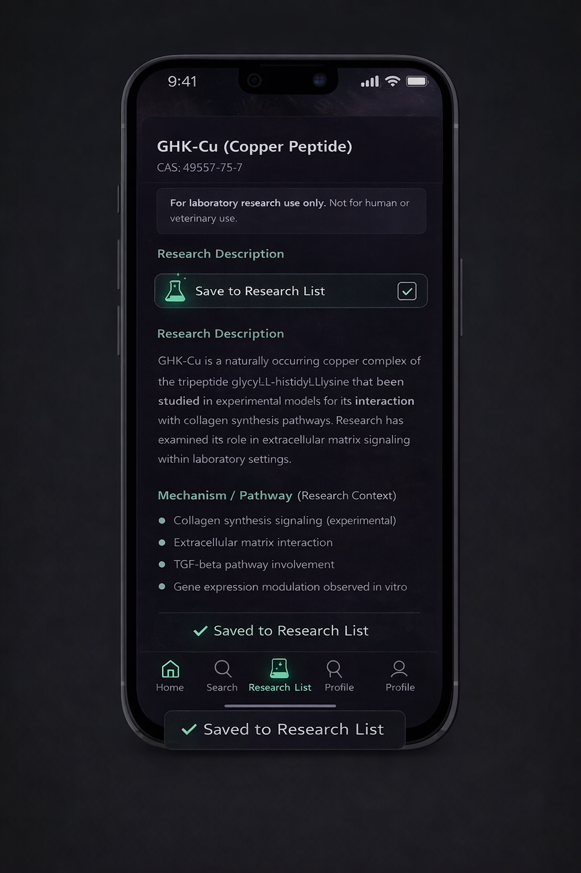

**DEV NOTE**

Disable the external (which is the button that opens up the shop) button when the list is empty

If no peptides are saved, hide or disable the button.

The external research link should only be visible when the Research List contains at least one saved compound. If the list is empty, the external link must be hidden.

Remove the weird gap between the research list icon and profil icon also it should be open third party external sources

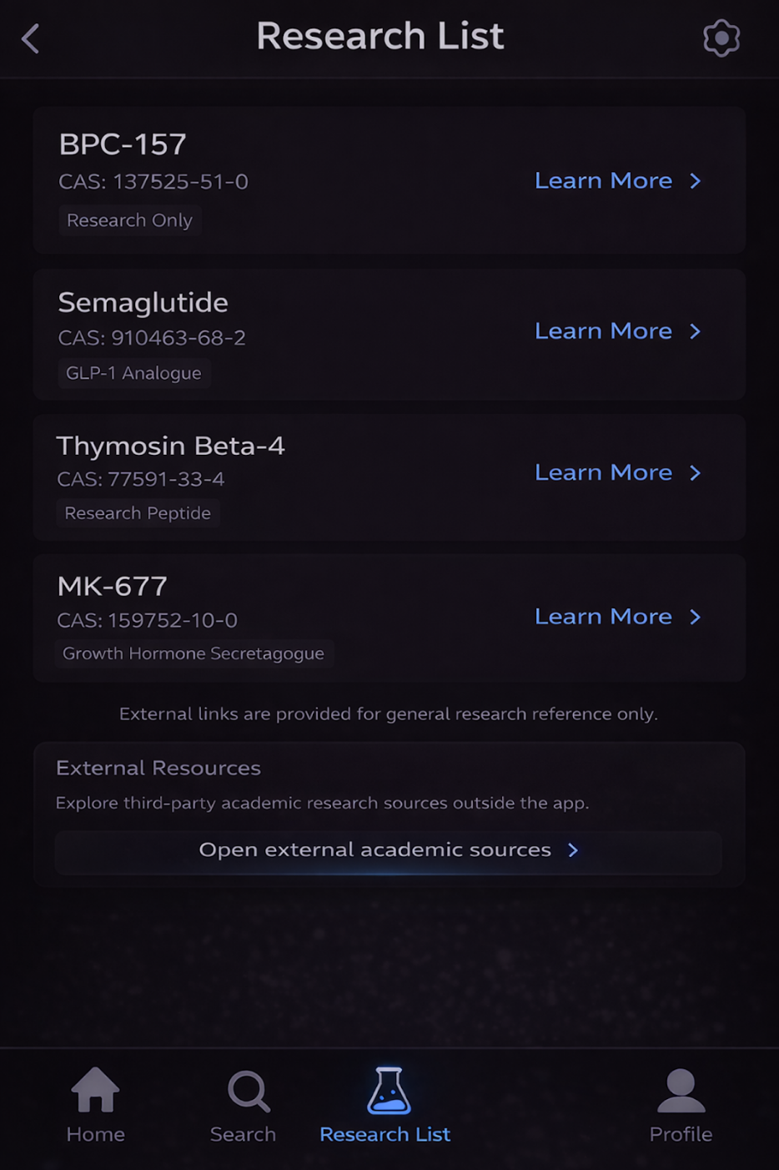

**Dev Notes**

Right before Safari opens when the user taps “Open third party externel  sources”. Not academic sources

Interstitial Screen (before Safari opens)

Title

Leaving the App

Body text

You are about to open a third-party website outside this app.

External sites are provided for general research and informational reference only and are not affiliated with or controlled by this app.

Buttons (two only)

Primary button (right / emphasized):

Open in Safari

Secondary button (left / subtle):

Cancel

**Dev Notes**

When tapped on the cog wheel on the top right corner of the research list it brings you to setting

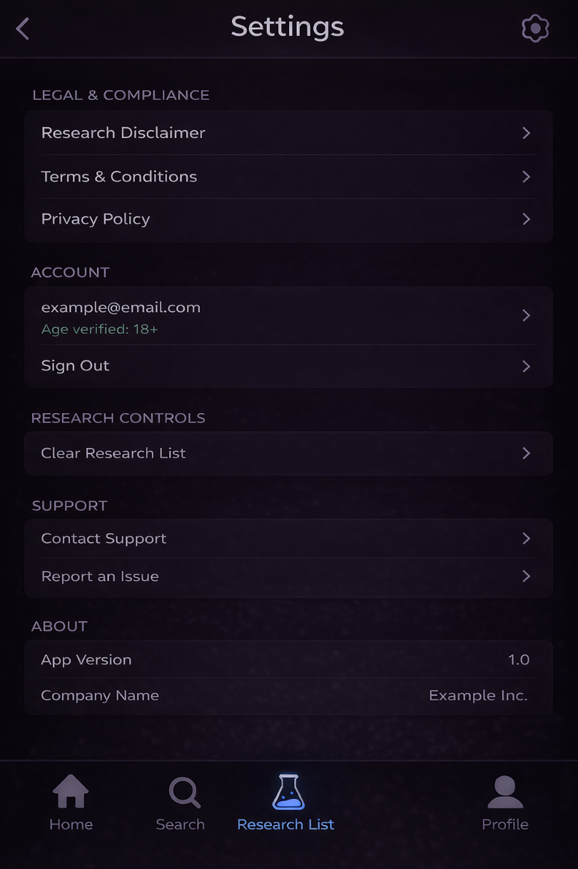

**Dev notes**

In settings once tapped onto research disclaimers all this informations should pop up

Research Disclaimer (screen title)

Section 1 — Purpose (top, short, clear)

Purpose of This App

This application is intended solely as an educational and informational research reference tool.

The information presented is designed to help users organize and review publicly available research information related to biochemical compounds.

Why this works:

Establishes intent immediately

Uses “educational” and “reference”

Section 2 — No Medical Use

No Medical or Therapeutic Use

This app does not provide medical advice, diagnostic guidance, treatment recommendations, or therapeutic instructions.

Information within the app should not be interpreted as medical, health, or clinical guidance.

Why this works:

Covers Apple + FDA expectations

No aggressive warnings

Section 3 — Research Use Only (important for your domain)

Research Context Only

Compounds referenced in this app are discussed strictly within a research and academic context.

Human applications, dosages, administration methods, or outcomes are not provided or established within this app.

Section 4 — External Links

External Resources

Any external links provided within the app lead to third-party websites for general research reference.

These external resources are not owned, operated, or controlled by this app, and the app does not endorse or guarantee their content.

Section 5 — User Responsibility

User Responsibility

Users are responsible for how they interpret and use information accessed through this app.

The app is not responsible for actions taken based on information viewed within or outside the app.

Section 6 — Closing line (

By using this app, you acknowledge and agree to this research disclaimer.

( no checkbox needed; passive acceptance is fine.)

**Dev note Terms and conditions**

**WHAT EXACTLY OPENS WHEN THEY TAP “TERMS & CONDITIONS”**

**It should open the SAME Terms document they accepted at onboarding.**

Nothing new. Nothing rewritten.  
 This screen is read-only.

Scrollable text  
Title at the top: Terms & Conditions  
Back arrow or Close button  
 No “Agree” button  
 No checkbox  
 No re-acceptance

Incase you forget

PART 1 — TERMS & CONDITIONS (EXACT COPY)

This is written specifically for your app as it exists now.

You can paste this directly into a doc or CMS.

Terms & Conditions

1. Acceptance of Terms

By accessing or using this application, you agree to be bound by these Terms & Conditions. If you do not agree, do not use the app.

2. Eligibility

You must be at least 21 years of age to access or use this app.

3. Purpose of the App

This app is provided solely for educational and informational research reference purposes.

The app is not intended to provide professional, medical, or clinical guidance.

4. No Medical Advice

The app does not provide medical advice, diagnosis, treatment, or healthcare services.

Information presented should not be relied upon for medical decisions.

5. No Commerce Within the App

The app does not sell, distribute, or process purchases of any products or substances.

Any references to compounds are provided strictly in a research and informational context.

6. Research Context Only

Compounds discussed in the app are referenced for research and academic purposes only.

Human applications, dosages, administration methods, or outcomes are not established or provided within the app.

7. Third-Party Websites

The app may include links to third-party websites for general research reference.

These websites are not owned, operated, or controlled by the app, and the app is not responsible for their content, products, or services.

8. User Responsibility

You are responsible for how you interpret and use information accessed through the app.

The app is not responsible for actions taken based on information viewed within or outside the app.

9. Disclaimer of Warranties

The app is provided “as is” and “as available” without warranties of any kind, express or implied.

10. Limitation of Liability

To the maximum extent permitted by law, the app shall not be liable for any damages arising from use of the app or reliance on its content.

11. Changes to These Terms

These Terms may be updated from time to time. Continued use of the app constitutes acceptance of any changes.

12. Contact

For questions regarding these Terms, contact:

[support@yourdomain.com

]

**Likewise for privacy once tapped this should pop up**

Privacy Policy

1. Overview

This Privacy Policy explains how this app collects, uses, and protects information when you use the app.

2. Information We Collect

We collect only the information necessary to operate the app and provide its features.

This may include:

Account information (such as email address)

App usage data related to saved research and preferences

Device and technical information (such as app version and device type)

We do not collect sensitive personal data.

3. How Information Is Used

Information collected is used solely to:

Provide and maintain app functionality

Save user preferences and research lists

Improve app performance and reliability

Communicate with users regarding app-related matters

4. Data Sharing

We do not sell, rent, or trade personal information.

Information may be shared only:

With service providers necessary to operate the app

When required by law

5. External Websites

The app may include links to third-party websites for general research reference.

We are not responsible for the privacy practices or content of third-party websites.

6. Data Security

We take reasonable measures to protect user information from unauthorized access, disclosure, or misuse.

7. User Rights

Users may request access to, correction of, or deletion of their account information by contacting support.

8. Children’s Privacy

This app is intended for users 21 years of age or older.

We do not knowingly collect information from individuals under 21.

9. Changes to This Policy

This Privacy Policy may be updated from time to time. Continued use of the app indicates acceptance of the updated policy.

10. Contact

For questions regarding this Privacy Policy, contact:

support@yourdomain.com

**Dev Notes**

When tapped into in profile it should look like this

